

j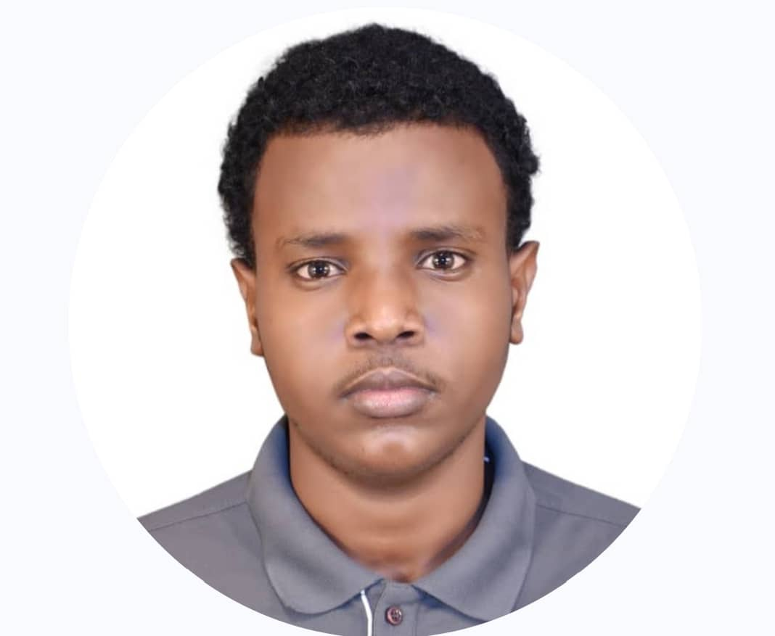

**Yahye Ahmed Shuqale**

*Faculty of Computing*

*Bachelor of Science Computer science*

***BCS17***

**ID No: CS231110713**